## ASSIGNMENT -7

## Library Module – Shared Library

1. **Create 3 files as below.**
   * **libapplication.c – will contain main() and will invoke functions in cal_utility.c**

This file will contain the ‘main()’ function and will invoke functions from ‘cal_utility.c’

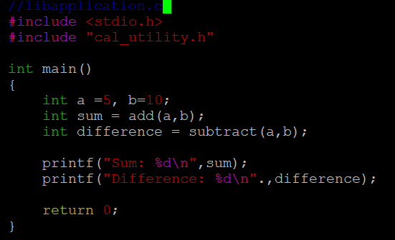

* + **cal_utility.c – will contain atleast 2 or more functions [ You may add definitions of the functions in this file]**

This file will contain at least two functions, such as ‘add’ and ‘subtract’.

* + **cal_utility.h – will contain the extern declarations/prototypes of the functions in cal_utility.c**

This header file will contain in the extern declarations/prototypes of the functions defined in ‘cal_utility.c’.

* With these files created, we can compile them together using a command shown in below.
* Then run the application by using ‘./myapplication’.
* This should display the sum and difference of the two numbers.

1. **Refer the steps for shared library and create a shared library comprising of cal_utility.c,.h files**

* Use the ‘-fPIC’ flag when compiling ‘cal_utility.c’. This flag tells the compiler to generate position – independent code, which is necessary for shared libraries.
* Use the ‘gcc’ command to create a shared library from the object file you just compiled.
* The naming convention for shared libraries in linux is to prefix the library name with ‘lib’ and suffix it with ‘.so’.

1. **Create an executable using shared library.**

* We have to link the shared library when compiling your application.

In this command:

* + ‘-L’ tells the compiler to look for libraries in the current directory.
  + ‘-lcal_utility’ links against the ‘libcal_utility.so’ library.

1. **Execute the application created step 3.**

* After compiling, run your application by using below command.

